**2014:**

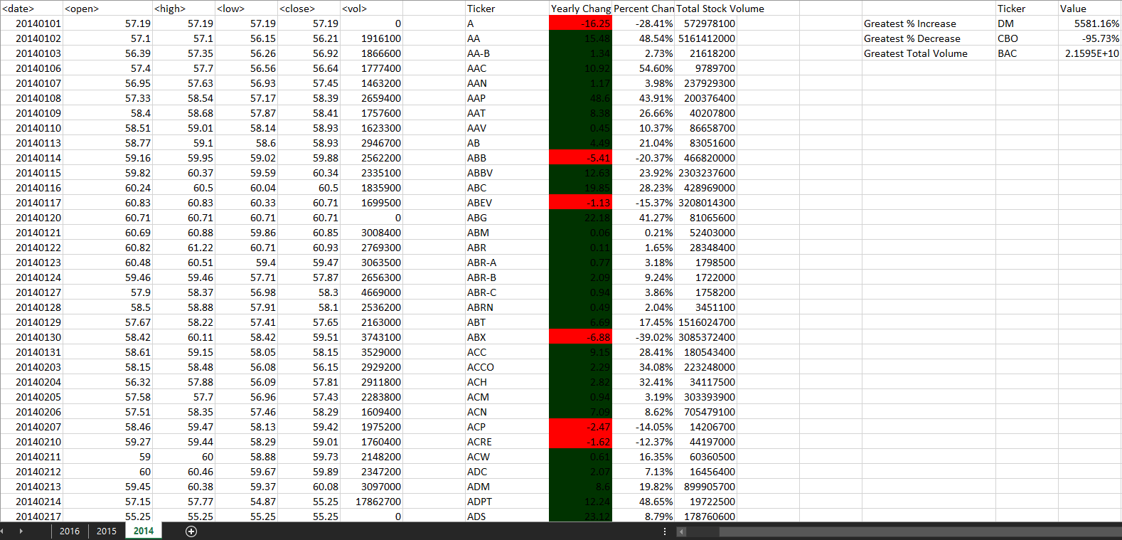

**2015:**

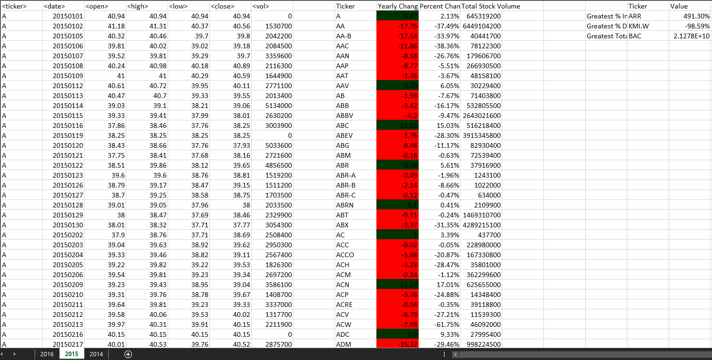

**2016:**

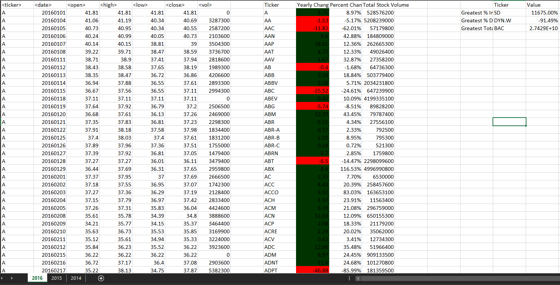

**VBA Script, if the Notepad attachment doesn’t work**

Sub HomeWorkData()

Dim WS As Worksheet

For Each WS In ActiveWorkbook.Worksheets

WS.Activate

LastRow = WS.Cells(Rows.Count, 1).End(xlUp).Row

Cells(1, "I").Value = "Ticker"

Cells(1, "J").Value = "Yearly Change"

Cells(1, "K").Value = "Percent Change"

Cells(1, "L").Value = "Total Stock Volume"

Dim Open_Price As Double

Dim Close_Price As Double

Dim Yearly_Change As Double

Dim Ticker As String

Dim Percent_Change As Double

Dim Volume As Double

Volume = 0

Dim Row As Double

Row = 2

Dim Column As Integer

Column = 1

Dim i As Long

Open_Price = Cells(2, Column + 2).Value

For i = 2 To LastRow

If Cells(i + 1, Column).Value <> Cells(i, Column).Value Then

Ticker = Cells(i, Column).Value

Cells(Row, Column + 8).Value = Ticker

Close_Price = Cells(i, Column + 5).Value

Yearly_Change = Close_Price - Open_Price

Cells(Row, Column + 9).Value = Yearly_Change

If (Open_Price = 0 And Close_Price = 0) Then

Percent_Change = 0

ElseIf (Open_Price = 0 And Close_Price <> 0) Then

Percent_Change = 1

Else

Percent_Change = Yearly_Change / Open_Price

Cells(Row, Column + 10).Value = Percent_Change

Cells(Row, Column + 10).NumberFormat = "0.00%"

End If

Volume = Volume + Cells(i, Column + 6).Value

Cells(Row, Column + 11).Value = Volume

Row = Row + 1

Open_Price = Cells(i + 1, Column + 2)

Volume = 0

Else

Volume = Volume + Cells(i, Column + 6).Value

End If

Next i

YCLastRow = WS.Cells(Rows.Count, Column + 8).End(xlUp).Row

For j = 2 To YCLastRow

If (Cells(j, Column + 9).Value >= 0) Then

Cells(j, Column + 9).Interior.ColorIndex = 51

ElseIf Cells(j, Column + 9).Value < 0 Then

Cells(j, Column + 9).Interior.ColorIndex = 3

End If

Next j

Cells(2, Column + 14).Value = "Greatest % Increase"

Cells(3, Column + 14).Value = "Greatest % Decrease"

Cells(4, Column + 14).Value = "Greatest Total Volume"

Cells(1, Column + 15).Value = "Ticker"

Cells(1, Column + 16).Value = "Value"

For Z = 2 To YCLastRow

If Cells(Z, Column + 10).Value = Application.WorksheetFunction.Max(WS.Range("K2:K" & YCLastRow)) Then

Cells(2, Column + 15).Value = Cells(Z, Column + 8).Value

Cells(2, Column + 16).Value = Cells(Z, Column + 10).Value

Cells(2, Column + 16).NumberFormat = "0.00%"

ElseIf Cells(Z, Column + 10).Value = Application.WorksheetFunction.Min(WS.Range("K2:K" & YCLastRow)) Then

Cells(3, Column + 15).Value = Cells(Z, Column + 8).Value

Cells(3, Column + 16).Value = Cells(Z, Column + 10).Value

Cells(3, Column + 16).NumberFormat = "0.00%"

ElseIf Cells(Z, Column + 11).Value = Application.WorksheetFunction.Max(WS.Range("L2:L" & YCLastRow)) Then

Cells(4, Column + 15).Value = Cells(Z, Column + 8).Value

Cells(4, Column + 16).Value = Cells(Z, Column + 11).Value

End If

Next Z

Next WS

End Sub